BTD310 – Fall 2017

# **Assignment 2**

# **7% of final mark**

Submit a page with a description of:

1. Your timeline for finishing the assignment with 3 to 5 milestones. Include team meetings or the questions you are going to finish by that date.

|  |  |
| --- | --- |
| Due Date | Milestone |
| Oct 20th, 2017 | 1,2 |
| Oct 24th, 2017 | 3,4,5 |
| Dec 1st,2017 | 6,7,8 |
| Dec 13th, 2017 | 7,9,10 |

1. How you are dividing the work among the group members (who is doing what?)

|  |  |
| --- | --- |
| Team Member | Tasks |
| **Khai** | 5, 8,10 |
| **Mahnoor** | 1,2,7 |
| **Hao** | 3,4,5,6,9 |

Submit all .sql files and script outputs with a clear table of contents.

In this assignment, you will be implementing a database for a company who rents out tools to contractors. More specifically, you will be implementing the following tables:

**RETAILER** [RETAILER_NUM (PK), RETAILER_NAME]

**TOOL** [TOOL_NUM (PK), TOOL_NAME, TOOL_COST, TOOL_LENGTH, TOOL_WIDTH, TOOL_HEIGHT, TOOL_WEIGHTCLASS, RETAILER_NUM(FK)]

**TOOLINSTANCE** [TI_NUM (PK), TOOL_NUM (PK, FK), TI_PURCHASEDATE, TI_STATUS]

**DETAILRENTAL** [RENT_NUM (PK, FK), TI_NUM (PK, FK), DETAIL_FEE, DETAIL_DUEDATE, DETAIL_RETURNDATE, DETAIL_DAILYLATEFEE]

**RENTAL** [RENT_NUM (PK), CONTRACTOR_NUM(FK), RENT_DATE]

**CONTRACTOR** [CONTRACTOR_NUM (PK), CONTRACTOR_NAME, CONTRACTOR_PHONE_NUM, COTRACTOR_ADDRESS_STREET, CONTRACTOR_ADDRESS_CITY, CONTRACTOR_ADDRESS_STATEPROV, CONTRACTOR_ADDRESS_ZIP, CONTRACTOR_JOIN_DATE]

## Part I. Table creation and data insertion

1. Create the tables based on the following charts. Save the SQL commands in **Asg2_Q1.sql**. Name the constraints using *tableName_columnName_constraint* format. For example, TOOL_TOOL_NAME_NN.

**CONTRACTOR** table

|  |  |  |  |  |  |
| --- | --- | --- | --- | --- | --- |
| Column Name | Key Type | Null/ Unique | Default Value | Data Type | Length |
| CONTRACTOR_NUM | PK | NN, U |  | NUMBER | 10 |
| CONTRACTOR_NAME |  | NN |  | VARCHAR2 | 25 |
| CONTRACTOR_PHONE_NUM |  | NN |  | VARCHAR2 | 15 |
| COTRACTOR_ADDRESS_STREET |  |  |  | VARCHAR2 | 100 |
| CONTRACTOR_ADDRESS_CITY |  |  |  | VARCHAR2 | 30 |
| CONTRACTOR_ADDRESS_STATEPROV |  |  | ON | VARCHAR2 | 20 |
| CONTRACTOR_ADDRESS_ZIP |  |  |  | VARCHAR2 | 10 |
| CONTRACTOR_JOIN_DATE |  | NN | System Date | DATE |  |

CREATE TABLE CONTRACTOR(CONTRACTOR_NUM NUMBER(10) PRIMARY KEY

CONSTRAINT CONT_CONTRACTOR_NUM_NN NOT NULL,

CONTRACTOR_NAME VARCHAR2(25)

CONSTRAINT CONT_CONTRACTOR_NAME_NN NOT NULL,

CONTRACTOR_PHONE_NUM VARCHAR2(15)

CONSTRAINT CONT_CONTRACTOR_PHONE_NUM_NN NOT NULL,

CONTRACTOR_ADDRESS_STREET VARCHAR2(100),

CONTRACTOR_ADDRESS_CITY VARCHAR2(30),

CONTRACTOR_ADDRESS_STATEPROV VARCHAR2(20) DEFAULT 'ON',

CONTRACTOR_ADDDRESS_ZIP VARCHAR2(10),

CONTRACTOR_JOIN_DATE DATE DEFAULT SYSDATE

CONSTRAINT CONT_CONTRACTOR_JOIN_DATE_NN NOT NULL

);

**RETAILER** table

|  |  |  |  |  |  |
| --- | --- | --- | --- | --- | --- |
| Column Name | Key Type | Null/ Unique | Default Value | Data Type | Length |
| RETAILER_NUM | PK | NN, U |  | NUMBER | 10 |
| RETAILER_NAME |  | NN |  | VARCHAR2 | 30 |

CREATE TABLE RETAILER(RETAILER_NUM NUMBER(10) NOT NULL

CONSTRAINT RET_RETAILER_NUM_PK PRIMARY KEY,

RETAILER_NAME VARCHAR2(30)

CONSTRAINT RET_RETAILER_NAME_NN NOT NULL

);

**TOOL** table

|  |  |  |  |  |  |
| --- | --- | --- | --- | --- | --- |
| Column Name | Key Type | Null/ Unique | Check | Data Type | Length |
| TOOL_NUM | PK | NN, U |  | NUMBER | 10 |
| TOOL_NAME |  | NN |  | VARCHAR2 | 100 |
| TOOL_COST |  |  | >= 0 | NUMBER | 10, 2 |
| TOOL_LENGTH |  |  | >= 0 | NUMBER | 10, 2 |
| TOOL_WIDTH |  |  | >= 0 | NUMBER | 10, 2 |
| TOOL_HEIGHT |  |  | >= 0 | NUMBER | 10, 2 |
| TOOL_WEIGHTCLASS |  |  | LIGHT, MEDIUM, MEDIUM HEAVY, HEAVY, VERY HEAVY | VARCHAR2 | 20 |
| RETAILER_NUM | FK | NN |  | NUMBER | 10 |

CREATE TABLE TOOL(TOOL_NUM NUMBER(10) PRIMARY KEY

CONSTRAINT TOOL_TOOLO_NUM_NN NOT NULL,

TOOL_NAME VARCHAR2(100)

CONSTRAINT TOOL_TOOL_NAME_NN NOT NULL,

TOOL_COST NUMBER(10,2)

CONSTRAINT TOOL_TOOL_COST_CK CHECK(TOOL_COST >= 0),

TOOL_LENGTH NUMBER(10,2)

CONSTRAINT TOOL_TOOL_LENGTH_CK CHECK(TOOL_LENGTH >= 0),

TOOL_WIDTH NUMBER(10,2)

CONSTRAINT TOOL_TOOL_WIDTH_CK CHECK(TOOL_WIDTH >= 0),

TOOL_HEIGHT NUMBER(10,2)

CONSTRAINT TOOL_TOOL_HEIGHT_CK CHECK(TOOL_HEIGHT >= 0),

TOOL_WEIGHTCLASS VARCHAR2(20)

CONSTRAINT TOOL_TOOL_WEIGHTCLASS_CK CHECK(TOOL_WEIGHTCLASS IN ('LIGHT','MEDIUM','MEDIUN HEAVY','HEAVY','VERY HEAVY')),

RETAILER_NUM NUMBER(10)

CONSTRAINT TOOL_RETAILER_NUM_NN NOT NULL,

FOREIGN KEY (RETAILER_NUM) REFERENCES RETAILER(RETAILER_NUM)

);

**TOOLINSTANCE** table

|  |  |  |  |  |  |  |
| --- | --- | --- | --- | --- | --- | --- |
| Column Name | Key Type | Null/ Unique | Default Value | Check | Data Type | Length |
| TI_NUM | PK | NN, U |  |  | NUMBER | 10 |
| TOOL_NUM | FK | NN |  |  | NUMBER | 10 |
| TI_PURCHASEDATE |  | NN | System Date |  | DATE |  |
| TI_STATUS |  | NN |  | Available, Destroyed, Rented | VARCHAR2 | 15 |

CREATE TABLE TOOLINSTANCE(TI_NUM NUMBER(10)PRIMARY KEY

CONSTRAINT T_TI_NUM_NN NOT NULL,

TOOL_NUM NUMBER(10)

CONSTRAINT T_TOOL_NUM_NN NOT NULL,

FOREIGN KEY (TOOL_NUM) REFERENCES TOOL(TOOL_NUM),

TI_PURCHASEDATE DATE DEFAULT SYSDATE

CONSTRAINT T_TI_PURCHASEDATE_NN NOT NULL,

TI_STATUS VARCHAR2(15) NOT NULL

CONSTRAINT T_TI_STATUS_CK CHECK(TI_STATUS IN ('Available','Destroyed','Rented'))

);

**DETAILRENTAL** table

|  |  |  |  |  |  |  |
| --- | --- | --- | --- | --- | --- | --- |
| Column Name | Key Type | Null/ Unique | Default Value | Check | Data Type | Length |
| RENT_NUM | PK, FK | NN, U |  |  | NUMBER | 10 |
| TI_NUM | PK, FK | NN, U |  |  | NUMBER | 10 |
| DETAIL_FEE |  | NN |  | >= 0 | NUMBER | 10, 2 |
| DETAIL_DAILYLATEFEE |  |  | 100.00 | >= 0 | NUMBER | 10, 2 |
| DETAIL_DUEDATE |  | NN |  |  | DATE |  |
| DETAIL_RETURNDATE |  |  |  |  | DATE |  |

CREATE TABLE DETAILRENTAL(RENT_NUM NUMBER(10)

CONSTRAINT DR_RENT_NUM_NN NOT NULL,

FOREIGN KEY (RENT_NUM) REFERENCES RENTAL(RENT_NUM),

TI_NUM NUMBER(10)

CONSTRAINT DR_TI_NUM NOT NULL,

FOREIGN KEY (TI_NUM) REFERENCES TOOLINSTANCE(TI_NUM),

DETAIL_FEE NUMBER(10)NOT NULL

CONSTRAINT DR_D_FEE_CK CHECK(DETAIL_FEE >= 0),

DETAIL_DAILYLATEFEE NUMBER(10) DEFAULT 100.00

CONSTRAINT DR_D_DF_CK CHECK(DETAIL_DAILYLATEFEE >= 0),

DETAIL_DUEDATE DATE

CONSTRAINT DR_D_DD_NN NOT NULL,

DETAIL_RETURNDATE DATE,

PRIMARY KEY(RENT_NUM, TI_NUM)

);

**RENTAL** table

|  |  |  |  |  |  |
| --- | --- | --- | --- | --- | --- |
| Column Name | Key Type | Null/ Unique | Default Value | Data Type | Length |
| RENT_NUM | PK | NN, U |  | NUMBER | 10 |
| CONTRACTOR _NUM | FK | NN |  | NUMBER | 10 |
| RENT_DATE |  | NN | System Date | DATE |  |

CREATE TABLE RENTAL(RENT_NUM NUMBER(10)PRIMARY KEY

CONSTRAINT RENTAL_RENT_NUM_NN NOT NULL,

CONTRACTOR_NUM NUMBER(10)

CONSTRAINT RENTAL_CONTRACTOR_NUM_NN NOT NULL,

FOREIGN KEY (CONTRACTOR_NUM) REFERENCES CONTRACTOR(CONTRACTOR_NUM),

RENT_DATE DATE DEFAULT SYSDATE

CONSTRAINT RENTAL_RENT_DATE_NN NOT NULL

);

1. Verify that the tables and constraints were created properly by checking the data dictionary. Save the output in **Asg2_Q2.txt.**

DESCRIBE CONTRACTOR;

DESCRIBE RETAILER;

DESCRIBE TOOL;

DESCRIBE TOOLINSTANCE;

DESCRIBE DETAILRENTAL;

DESCRIBE RENTAL;

1. Create sequences to uniquely identify each row in the CONTRACTOR, RETAILER, RENT, and TOOL tables as follows:
   1. Contractor number for the CONTRACTOR table: Start with 101; do not allow caching of the values. Name the sequence CONTRACTOR_NUM_SEQ.

CREATE SEQUENCE CONTRACTOR_NUM_SEQ

START WITH 101

NOCACHE;

* 1. Retailer number for the RETAILER table: Start with 1; do not allow caching of the values. Name the sequence RETAILER_NUM_SEQ.  
     CREATE SEQUENCE RETAILER_NUM_SEQ

START WITH 1

NOCACHE;

* 1. Rent number for the RENT table: Start with 100001; Go up to 999999; cycle through the numbers; do not allow caching of the values. Name the sequence RENT_NUM_SEQ.

CREATE SEQUENCE RENT_NUM_SEQ

START WITH 100001

MAXVALUE 999999

NOCACHE

CYCLE;

* 1. Tool number for the TOOL table: Start with 9999; *decrement* 2; do not allow caching of the values. Name the sequence TOOL_NUM_SEQ.

CREATE SEQUENCE TOOL_NUM_SEQ

START WITH 9999

MAXVALUE 10000

INCREMENT BY -2

NOCACHE;

Save the statements in a script named **Asg2_Q3.sql.**

1. Add data to the tables. Create a script to enter the information. Save the statements in a script named **Asg2_Q4.sql**. Query all rows of all tables and save output in **Asg2_Q4.txt**.
   1. Add the following tools to the TOOL and the Retailer tables. You need the Retailer number to enter tools. Use RETAILER_NUM_SEQ for RETAILER_NUM and TOOL_NUM_SEQ for TOOL_NUM. Note the single quotation mark in Retailer name.

|  |  |  |  |  |  |  |
| --- | --- | --- | --- | --- | --- | --- |
| Name | Cost | Length | Width | Height | Weight | Retailer |
| Tractor / mower | 5001.99 | 100 | 20 | 150 | HEAVY | John Deer |
| Tree pruning shears | 499.50 | 100 | 20 | 5 | MEDIUM | XXX’s manufacturing |
| Grass trimmer | 150.89 | 100 | 30 | 30 | LIGHT | Johnson |
| Tractor | 6000.00 | 100 | 30 | 200 | VERY HEAVY | YYY Tractors |

INSERT INTO RETAILER(RETAILER_NUM, RETAILER_NAME) VALUES (RETAILER_NUM_SEQ.NEXTVAL,'John Deer');

INSERT INTO RETAILER(RETAILER_NUM, RETAILER_NAME) VALUES (RETAILER_NUM_SEQ.NEXTVAL,'XXX''s manufacturing');

INSERT INTO RETAILER(RETAILER_NUM, RETAILER_NAME) VALUES (RETAILER_NUM_SEQ.NEXTVAL,'Johnson');

INSERT INTO RETAILER(RETAILER_NUM, RETAILER_NAME) VALUES (RETAILER_NUM_SEQ.NEXTVAL,'YYY Tractors');

INSERT INTO TOOL

SELECT TOOL_NUM_SEQ.NEXTVAL,'Tractor/mower',5001.99,100,20,150,'HEAVY', RETAILER_NUM FROM RETAILER WHERE RETAILER_NAME='John Deer';

INSERT INTO TOOL

SELECT TOOL_NUM_SEQ.NEXTVAL,'Tree pruning shears',499.50,100,20,5,'MEDIUM',RETAILER_NUM FROM RETAILER WHERE RETAILER_NAME='XXX''s manufacturing';

INSERT INTO TOOL

SELECT TOOL_NUM_SEQ.NEXTVAL,'Grass trimmer',150.89,100,30,30,'LIGHT',RETAILER_NUM FROM RETAILER WHERE RETAILER_NAME='Johnson';

INSERT INTO TOOL

SELECT TOOL_NUM_SEQ.NEXTVAL,'Tractor',6000.00,100,30,200,'VERY HEAVY',RETAILER_NUM FROM RETAILER WHERE RETAILER_NAME='YYY Tractors';

* 1. Add the following contractors to the CONTRACTOR table. Use CONTRACTOR_NUM_SEQ for CONTRACTOR_NUM. Enter the dates in DD-MON-YYYY format.

|  |  |  |  |  |  |  |
| --- | --- | --- | --- | --- | --- | --- |
| Name | Phone number | Street | City | State/province | ZIP | Join Date |
| Carmen’s | 905-111-2222 | 285 King Street | King City | ON | L5C 2X6 | 08-MAR-1990 |
| Audry’s | 647-666-8888 | 86 Chu Street | North York | ON | M2A 4X9 | 18-JAN-1991 |
| John Adams | 416-555-9999 | 234 Bloor W | Toronto | ON | M2S 4S3 | 05-JUL-2002 |
| ABC Contractors | 416-123-4567 | 123 Pond Road | North York | ON | M3J 1P3 | 19-OCT-2016 |

INSERT INTO CONTRACTOR

VALUES (CONTRACTOR_NUM_SEQ.nextval,'Carmen''s','905-111-2222','285 King Street','King City','ON', 'L5C 2X6', to_date('08-MAR-1990','DD-MON-YYYY'));

INSERT INTO CONTRACTOR

VALUES (CONTRACTOR_NUM_SEQ.nextval,'Audry''s','647-666-8888','86 Chu Street','North York','ON', 'M2A 4X9', to_date('18-JAN-1991','DD-MON-YYYY'));

INSERT INTO CONTRACTOR

VALUES (CONTRACTOR_NUM_SEQ.nextval,'John Adams','416-555-9999','234 Bloor W','Toronto','ON', 'M2S 4S3', to_date('05-JUL-2002','DD-MON-YYYY'));

INSERT INTO CONTRACTOR

VALUES (CONTRACTOR_NUM_SEQ.nextval,'ABC Contractors','416-123-4567','123 Pond Road','North York','ON', 'M3J 1P3', to_date('19-OCT-2016','DD-MON-YYYY'));

* 1. Add the following tool instances in the TOOLINSTANCE table. You need the TOOL_NUM values from the TOOL table.

|  |  |  |  |  |  |  |
| --- | --- | --- | --- | --- | --- | --- |
| Contractor | Rent date | TI_NUM | Fee | Daily Late Fee | Due Date | Return Date |
| Carmen’s | 01-FEB-2012 | 11 | 100 | 20 | 01-AUG-2012 | 15-JUL-2012 |
| Carmen’s | 15-JUL-2014 | 12 | 200 | 50 | 01-SEP-2015 | 30-AUG-2015 |
| Carmen’s | 30-AUG-2015 | 12 | 200 | 50 | 01-SEP-2016 |  |
| John Adams | 01-OCT-2016 | 16 | 45 | 10 | 15-DEC-2016 |  |
| Audry’s | 03-AUG-2015 | 17 | 50 | 10 | 01-OCT-2015 | 15-OCT-2015 |
| ABC Contractors | 10-JUL-2015 | 20 | 50 | 10 | 01-SEP-2015 | 25-AUG-2015 |
| Audry’s | 15-AUG-2016 | 21 | 50 | 10 | 01-NOV-2016 |  |
| John Adams | 01-MAR-2016 | 20 | 55 | 15 | 01-AUG-2016 | 15-OCT-2016 |

|  |  |  |  |
| --- | --- | --- | --- |
| Tool Retailer, name | TI_NUM | Purchase Date | Status |
| John Deer, Tractor / mower | 11 | 01-JAN-2012 | Destroyed |
| 12 | 01-JUL-2014 | Rented |
| 13 | 15-AUG-2016 | Available |
| YYY Tractors, Tractor | 14 | 20-AUG-2016 | Available |
| 15 | 20-Aug-2016 | Available |
| Johnson, Grass trimmer | 16 | 01-MAR-2013 | Rented |
| 17 | 03-APR-2014 | Rented |
| 18 | 05-MAY-2014 | Destroyed |
| 19 | 07-JUN-2015 | Destroyed |
| 20 | 09-JUL-2015 | Rented |
| 21 | 11-AUG-2016 | Rented |
| XXX’s manufacturing, Tree pruning shears | 22 | 01-MAY-2016 | Available |
| 23 | 01-MAY-2016 | Available |

INSERT INTO TOOLINSTANCE

SELECT 11,tool_num, to_date('01-JAN-2012','DD-MON-YYYY'),'Destroyed' FROM TOOL WHERE TOOL.TOOL_NAME = 'Tractor/mower';

INSERT INTO TOOLINSTANCE

SELECT 12,tool_num, to_date('01-JUL-2014','DD-MON-YYYY'),'Rented' FROM TOOL WHERE TOOL.TOOL_NAME = 'Tractor/mower';

INSERT INTO TOOLINSTANCE

SELECT 13,tool_num, to_date('15-AUG-2016','DD-MON-YYYY'),'Available' FROM TOOL WHERE TOOL.TOOL_NAME = 'Tractor/mower';

INSERT INTO TOOLINSTANCE

SELECT 14,tool_num, to_date('20-Aug-2016','DD-MON-YYYY'),'Available' FROM TOOL WHERE TOOL.TOOL_NAME = 'Tractor';

INSERT INTO TOOLINSTANCE

SELECT 15,tool_num, to_date('20-Aug-2016','DD-MON-YYYY'),'Available' FROM TOOL WHERE TOOL.TOOL_NAME = 'Tractor';

INSERT INTO TOOLINSTANCE

SELECT 16,tool_num, to_date('01-MAR-2013','DD-MON-YYYY'),'Rented' FROM TOOL WHERE TOOL.TOOL_NAME = 'Grass trimmer';

INSERT INTO TOOLINSTANCE

SELECT 17,tool_num, to_date('03-APR-2014','DD-MON-YYYY'),'Rented' FROM TOOL WHERE TOOL.TOOL_NAME = 'Grass trimmer';

INSERT INTO TOOLINSTANCE

SELECT 18,tool_num, to_date('05-MAY-2014','DD-MON-YYYY'),'Destroyed' FROM TOOL WHERE TOOL.TOOL_NAME = 'Grass trimmer';

INSERT INTO TOOLINSTANCE

SELECT 19,tool_num, to_date('07-JUN-2015','DD-MON-YYYY'),'Destroyed' FROM TOOL WHERE TOOL.TOOL_NAME = 'Grass trimmer';

INSERT INTO TOOLINSTANCE

SELECT 20,tool_num, to_date('09-JUL-2015','DD-MON-YYYY'),'Rented' FROM TOOL WHERE TOOL.TOOL_NAME = 'Grass trimmer';

INSERT INTO TOOLINSTANCE

SELECT 21,tool_num, to_date('11-AUG-2016','DD-MON-YYYY'),'Rented' FROM TOOL WHERE TOOL.TOOL_NAME = 'Grass trimmer';

INSERT INTO TOOLINSTANCE

SELECT 22,tool_num, to_date('01-MAY-2016','DD-MON-YYYY'),'Available' FROM TOOL WHERE TOOL.TOOL_NAME = 'Tree pruning shears';

INSERT INTO TOOLINSTANCE

SELECT 23,tool_num, to_date('01-MAY-2016','DD-MON-YYYY'),'Available' FROM TOOL WHERE TOOL.TOOL_NAME = 'Tree pruning shears';

* 1. Add the following rentals to the RENTAL and DETAILRENTAL tables. Use the appropriate sequence. You need the contractor numbers from the CONTRACTOR table.

|  |  |  |  |  |  |  |
| --- | --- | --- | --- | --- | --- | --- |
| Contractor | Rent date | TI_NUM | Fee | Daily Late Fee | Due Date | Return Date |
| Carmen’s | 01-FEB-2012 | 11 | 100 | 20 | 01-AUG-2012 | 15-JUL-2012 |
| Carmen’s | 15-JUL-2014 | 12 | 200 | 50 | 01-SEP-2015 | 30-AUG-2015 |
| Carmen’s | 30-AUG-2015 | 12 | 200 | 50 | 01-SEP-2016 |  |
| John Adams | 01-OCT-2016 | 16 | 45 | 10 | 15-DEC-2016 |  |
| Audry’s | 03-AUG-2015 | 17 | 50 | 10 | 01-OCT-2015 | 15-OCT-2015 |
| ABC Contractors | 10-JUL-2015 | 20 | 50 | 10 | 01-SEP-2015 | 25-AUG-2015 |
| Audry’s | 15-AUG-2016 | 21 | 50 | 10 | 01-NOV-2016 |  |
| John Adams | 01-MAR-2016 | 20 | 55 | 15 | 01-AUG-2016 | 15-OCT-2016 |

INSERT INTO RENTAL

SELECT RENT_NUM_SEQ.nextval, contractor_num,to_date('01-FEB-2012','DD-MON-YYYY') FROM CONTRACTOR WHERE CONTRACTOR_NAME = 'Carmen''s';

INSERT INTO DETAILRENTAL

SELECT RENT_NUM_SEQ.currval,11,100,20, to_date('01-AUG-2012','DD-MON-YYYY'),to_date('15-JUL-2012','DD-MON-YYYY') FROM SYS.DUAL;

INSERT INTO RENTAL

SELECT RENT_NUM_SEQ.nextval, contractor_num,to_date('15-JUL-2014','DD-MON-YYYY') FROM CONTRACTOR where CONTRACTOR_NAME = 'Carmen''s';

INSERT INTO DETAILRENTAL

SELECT RENT_NUM_SEQ.currval,12,200,50, to_date('01-SEP-2015','DD-MON-YYYY'),to_date('30-AUG-2015','DD-MON-YYYY') FROM SYS.DUAL;

INSERT INTO RENTAL

SELECT RENT_NUM_SEQ.nextval, contractor_num,to_date('30-AUG-2015','DD-MON-YYYY') FROM CONTRACTOR WHERE CONTRACTOR_NAME = 'Carmen''s';

INSERT INTO DETAILRENTAL

SELECT RENT_NUM_SEQ.currval,12,200,50, to_date('01-SEP-2016','DD-MON-YYYY'), null from sys.dual;

INSERT INTO RENTAL

SELECT RENT_NUM_SEQ.nextval, contractor_num,to_date('01-OCT-2016','DD-MON-YYYY') FROM CONTRACTOR WHERE CONTRACTOR_NAME = 'John Adams';

INSERT INTO DETAILRENTAL

SELECT RENT_NUM_SEQ.currval,16,45,10, to_date('15-DEC-2016','DD-MON-YYYY'), null FROM sys.dual;

INSERT INTO RENTAL

SELECT RENT_NUM_SEQ.nextval, contractor_num,to_date('03-AUG-2015','DD-MON-YYYY') FROM CONTRACTOR WHERE CONTRACTOR_NAME = 'Audry''s';

INSERT INTO DETAILRENTAL

SELECT RENT_NUM_SEQ.currval,17,50,10, to_date('01-OCT-2015','DD-MON-YYYY'), to_date('15-OCT-2015','DD-MON-YYYY') FROM sys.dual;

INSERT INTO RENTAL

SELECT RENT_NUM_SEQ.nextval, contractor_num,to_date('10-JUL-2015','DD-MON-YYYY') FROM CONTRACTOR WHERE CONTRACTOR_NAME = 'ABC Contractors';

INSERT INTO DETAILRENTAL

SELECT RENT_NUM_SEQ.currval,20,50,10, to_date('01-SEP-2015','DD-MON-YYYY'), to_date('25-AUG-2015','DD-MON-YYYY') FROM sys.dual;

INSERT INTO RENTAL

SELECT RENT_NUM_SEQ.nextval, contractor_num,to_date('15-AUG-2016','DD-MON-YYYY') FROM CONTRACTOR WHERE CONTRACTOR_NAME = 'Audry''s';

INSERT INTO DETAILRENTAL

SELECT RENT_NUM_SEQ.currval,21,50,10, to_date('01-NOV-2016','DD-MON-YYYY'), null FROM sys.dual;

INSERT INTO RENTAL

SELECT RENT_NUM_SEQ.nextval, contractor_num,to_date('01-MAR-2016','DD-MON-YYYY') FROM CONTRACTOR WHERE CONTRACTOR_NAME = 'John Adams';

INSERT INTO DETAILRENTAL

SELECT RENT_NUM_SEQ.currval,20,55,15, to_date('01-AUG-2016','DD-MON-YYYY'), to_date('15-OCT-2016','DD-MON-YYYY') FROM sys.dual;

## Part II: Creating Views

**Save the SQL statement for questions 5 to 9 in Asg2_PartII.sql. Save the outputs in Asg2_PartII.txt.**

1. Create a view named AVAIL_TOOLS that displays a list of available tools and rented tools that are not overdue. For the rented items, show the expected availability date. For available tools, show expected date as “Now”. Sort by the tool name. (Do not include destroyed tools, or those who are not returned by their due date.) Querying all rows in this view should give you the following rows:

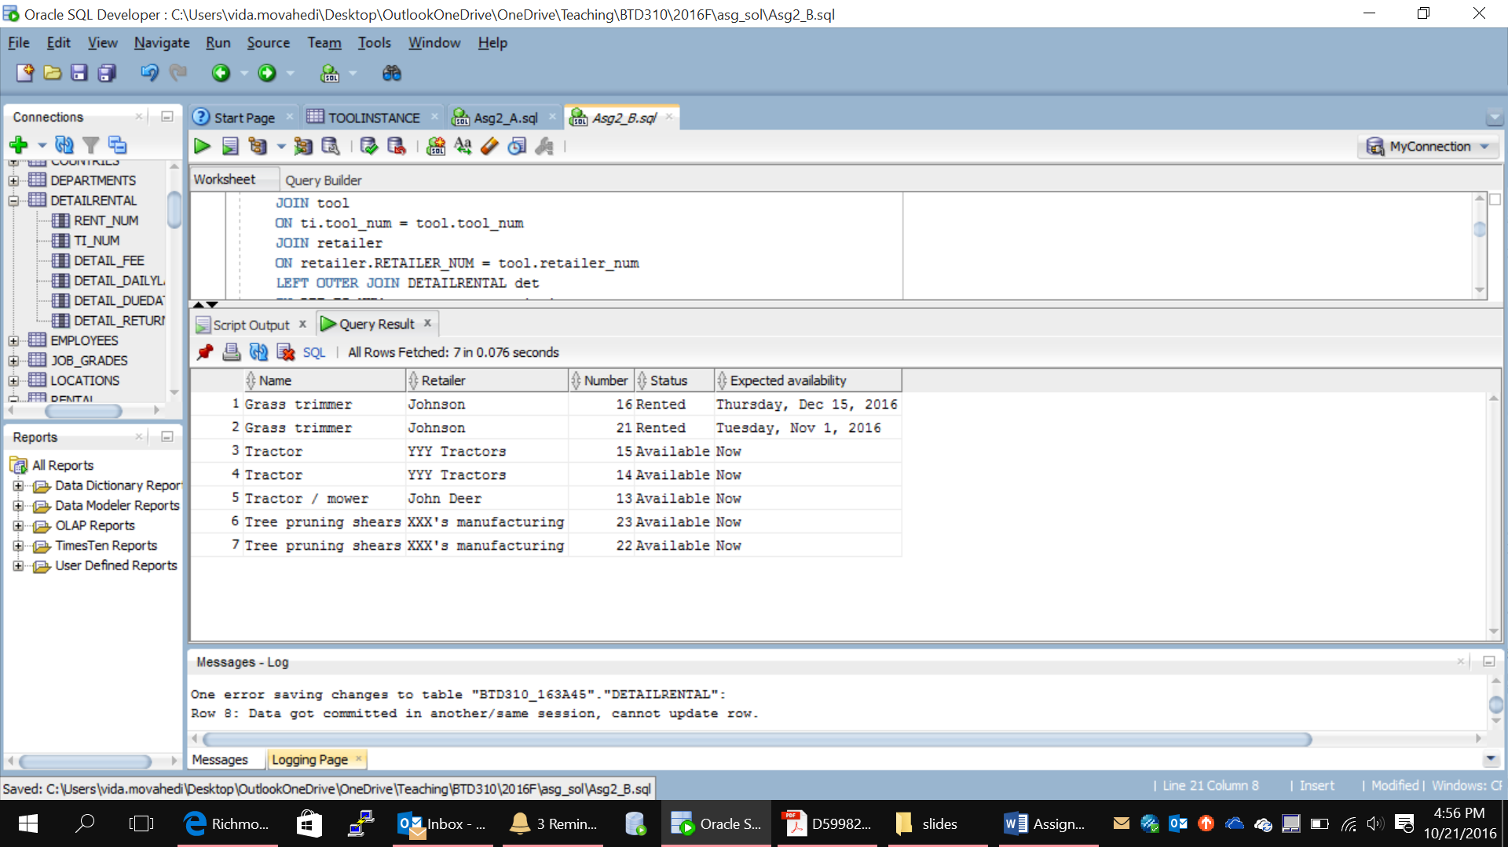

CREATE VIEW Avail_Tools AS

SELECT T.TOOL_NAME as "Name", R.RETAILER_NAME as "Retailer", TI.TI_NUM as "Number",

TI.TI_STATUS as "Status",

DECODE(TI.TI_STATUS, 'Available', 'Now',

DETAIL_DUEDATE) as "Expected Availability"

FROM RETAILER R JOIN TOOL T ON R.RETAILER_NUM = T.RETAILER_NUM

JOIN TOOLINSTANCE TI ON T.TOOL_NUM = TI.TOOL_NUM

JOIN DETAILRENTAL D ON TI.TI_NUM = D.TI_NUM

WHERE TI.TI_STATUS <> 'Destroyed' AND D.DETAIL_RETURNDATE < D.DETAIL_DUEDATE

AND D.DETAIL_RETURNDATE <> 'null'

ORDER BY T.TOOL_NAME;

SELECT *

FROM AVAIL_TOOLS;

DROP VIEW Avail_Tools;

1. As the above view is prepared, you notice that some tools are returned, but are still listed as “Rented” as their status. Write a query to list these tool instances. You should get instance numbers 17 and 20.

(Hint. The return dates of these tools are earlier than the current system date.)

1. Write a statement that updates the status of the tool instances in Question 6 to “Available”. Now query all rows in AVAIL_TOOLS. You should get these now:

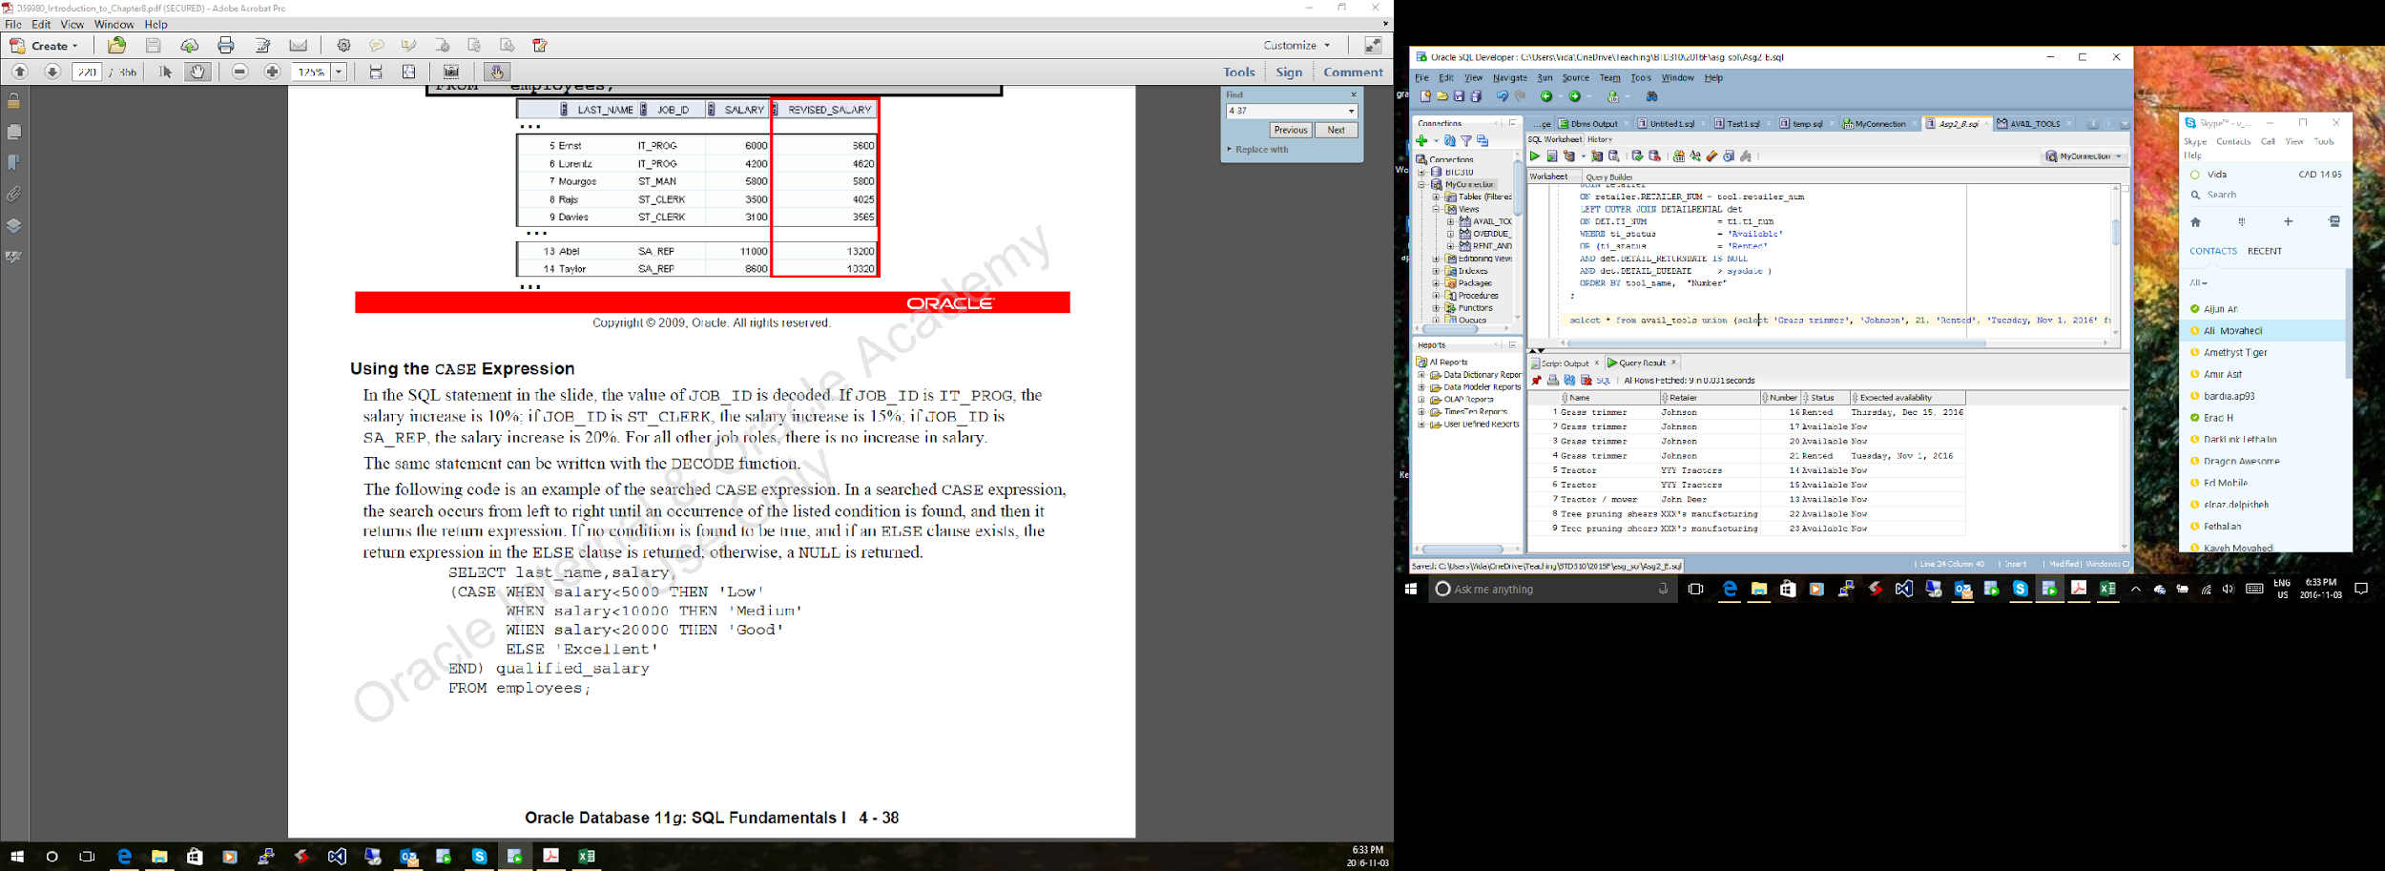

1. To follow up with contractors that have an overdue item rented, create a view named OVERDUE_TOOLS that displays the contractor name and phone number, the tool they rented, the rent date and the due date for any items that are overdue. On Oct. 21, querying this view gives the following information (your output might look different based on when you query this view):

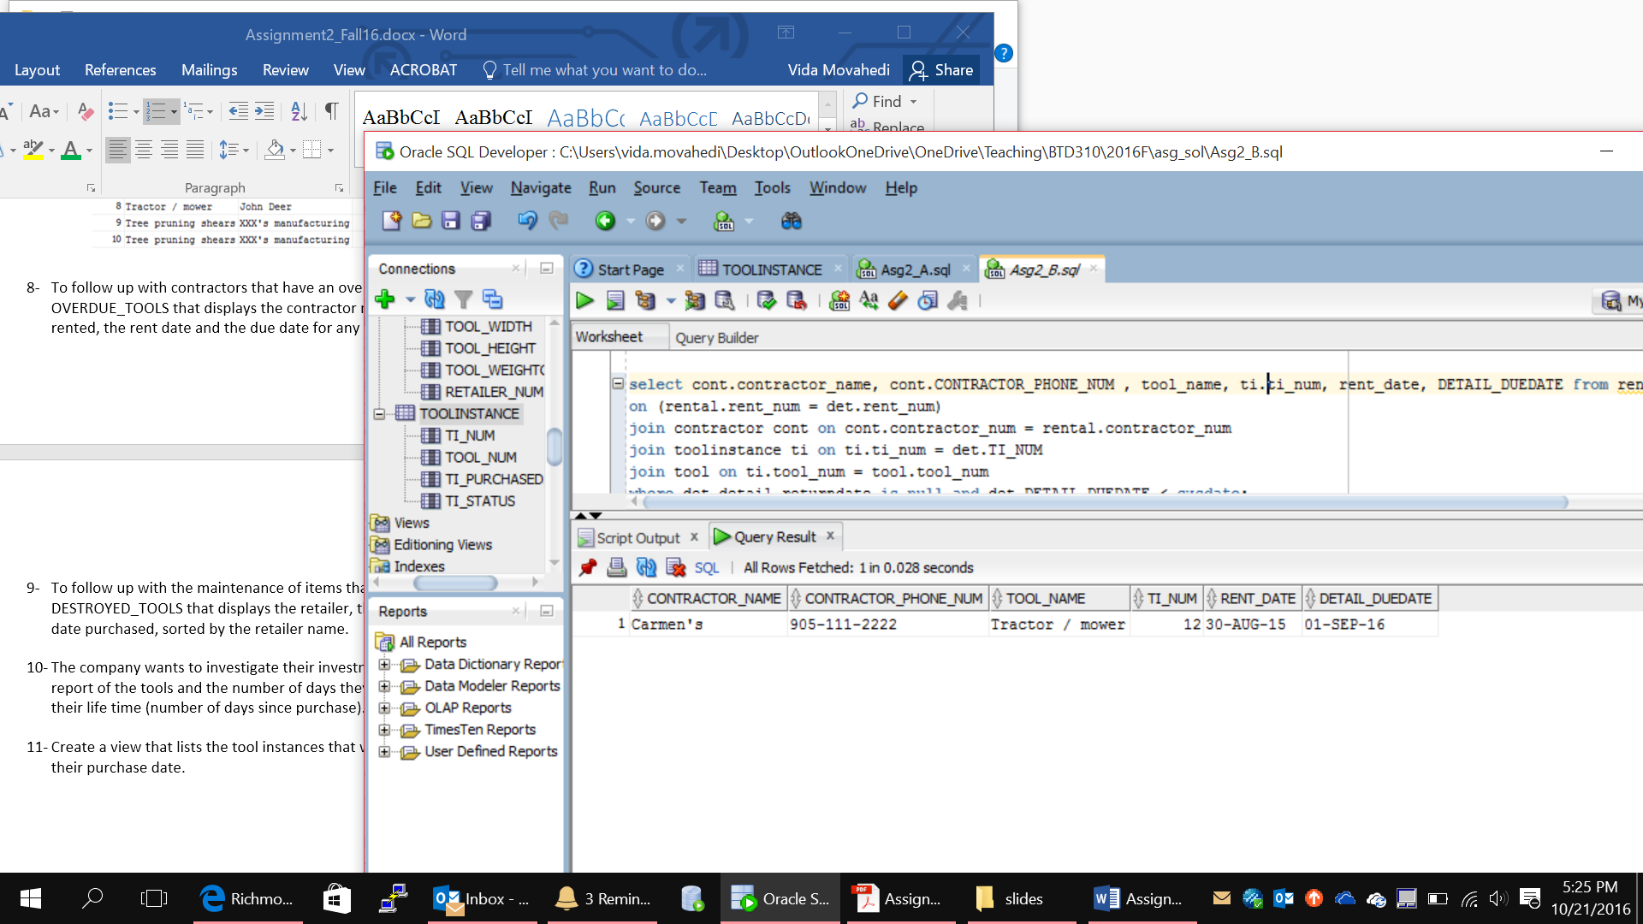

CREATE VIEW OVERDUE_TOOLS AS

SELECT C.CONTRACTOR_NAME, C.CONTRACTOR_PHONE_NUM, T.TOOL_NAME,

TI.TI_NUM, R.RENT_DATE, D.DETAIL_DUEDATE

FROM CONTRACTOR C JOIN RENTAL R ON C.CONTRACTOR_NUM = R.CONTRACTOR_NUM

JOIN DETAILRENTAL D ON R.RENT_NUM = D.RENT_NUM

JOIN TOOLINSTANCE TI ON D.TI_NUM = TI.TI_NUM

JOIN TOOL T ON TI.TOOL_NUM = T.TOOL_NUM

WHERE D.DETAIL_DUEDATE < D.DETAIL_RETURNDATE;

SELECT *

FROM OVERDUE_TOOLS;

DROP VIEW OVERDUE_TOOLS;

1. The company wants to investigate their inventory. To get an idea, the manager wants a report of the tools and the number of days they have been rented out versus their life time (number of days since purchase). If an item is not returned yet, assume they are returned today. Order by tool instance number.

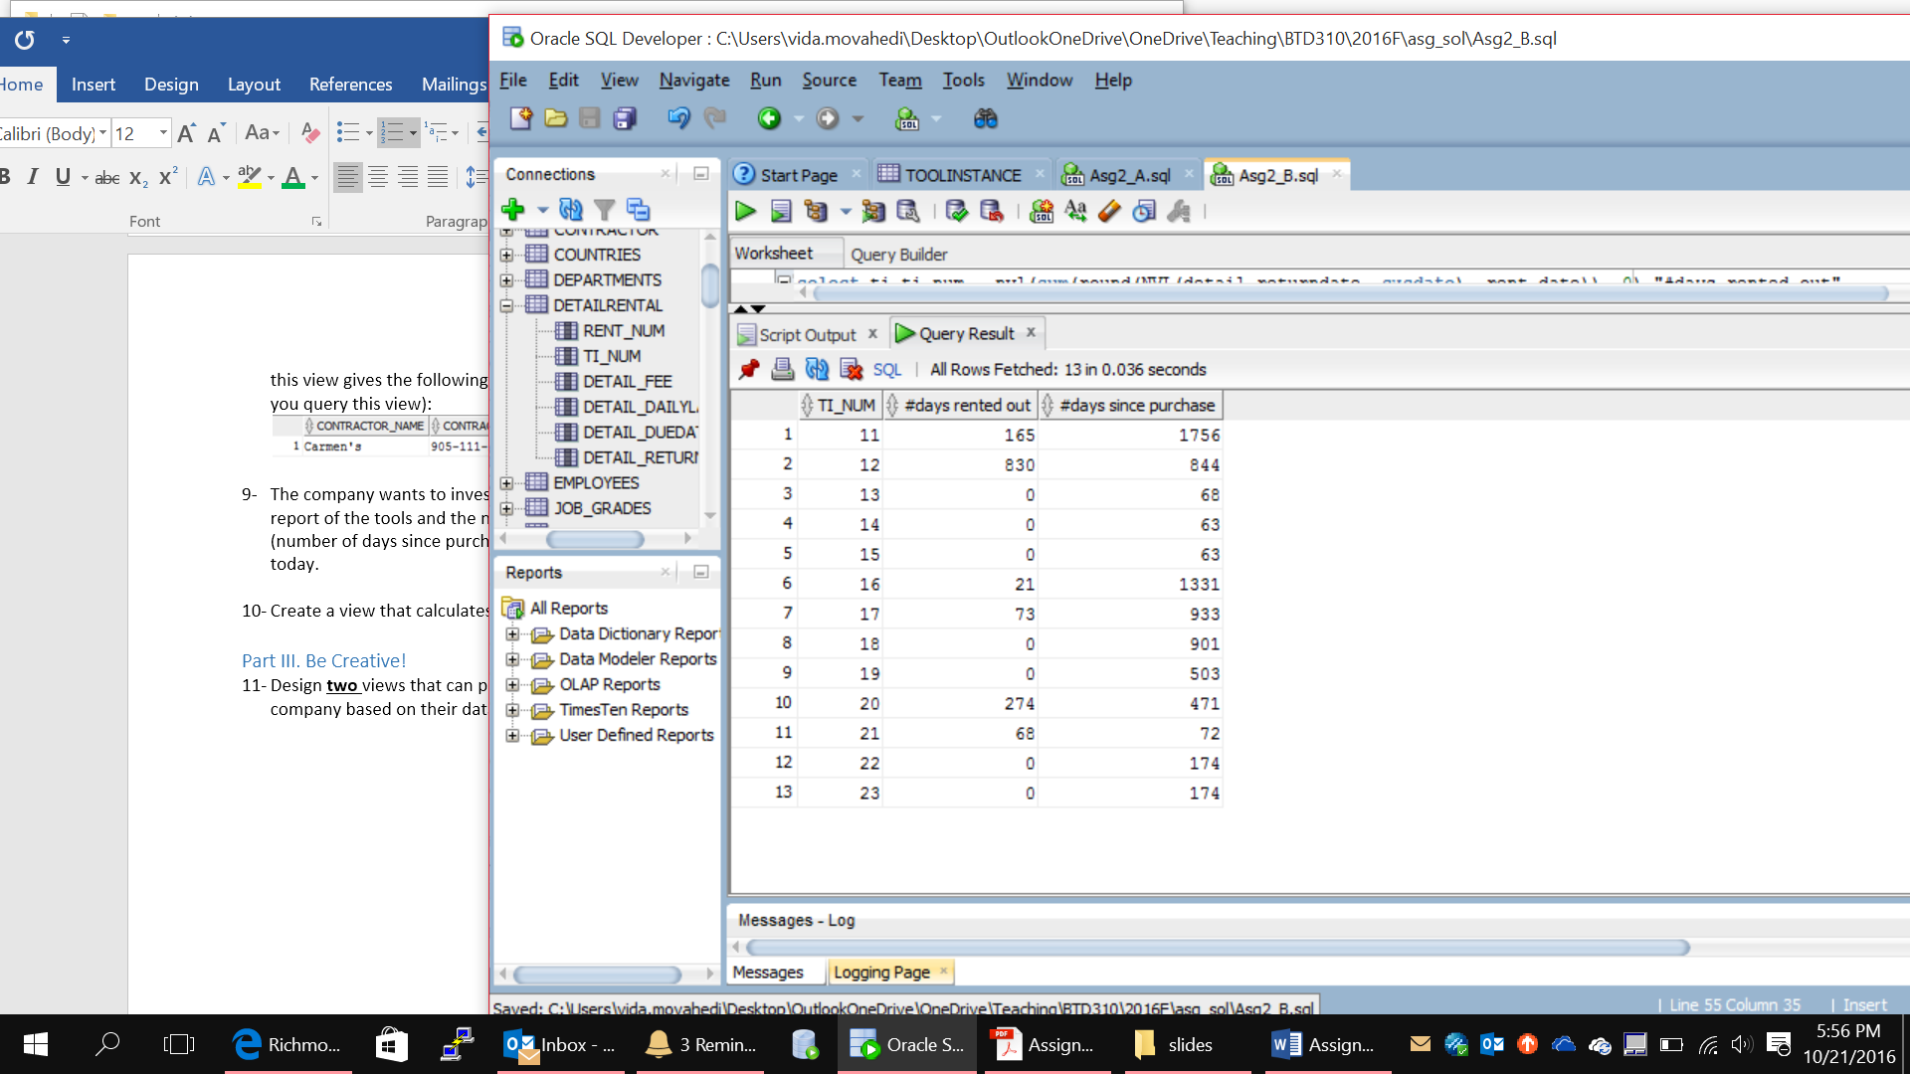

## Part III. Be Creative!

**Save the SQL statement for question 10 in Asg2_PartIII.sql. Save the outputs in Asg2_PartIII.txt.**

1. Design **two** views that can provide not so obvious information to the manager of this company based on their data. Provide the SQL statements as well as a short description of what it reveals.

**Submit the following files:**

|  |  |
| --- | --- |
| Asg2_Q1.sql | Asg2_Q2.txt |
| Asg2_Q3.sql |  |
| Asg2_Q4.sql | Asg2_Q4.txt |
| Asg2_PartII.sql | Asg2_PartII.txt |
| Asg2_PartIII.sql | Asg2_PartIII.txt |

**Also, include what each member has done:**

|  |  |  |
| --- | --- | --- |
| Team Member 1 | Team Member 2 | Team Member 3 |
| (make this list as long as necessary) |  |  |